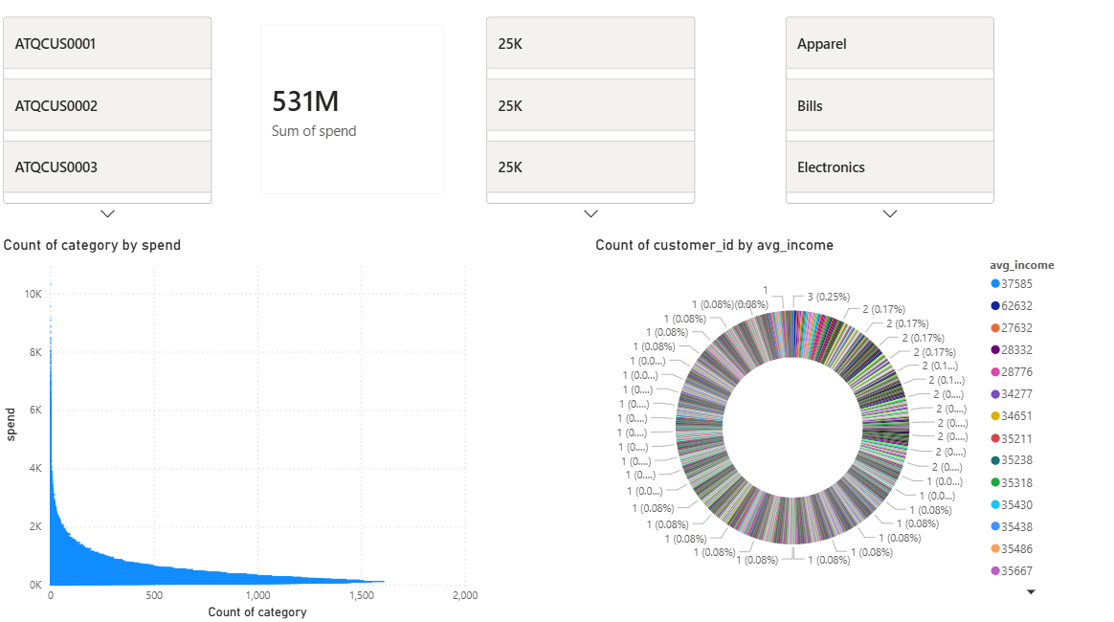
💳 Customer Spending Overview
- Total customer spend stands at 531M, indicating strong overall spending activity
- Spending is highly skewed, with a small set of categories driving most of the value
- Customer base spans wide income ranges, showing a diversified but fragmented income profile
- High-frequency low-value spends dominate, highlighting volume-led consumption behaviour
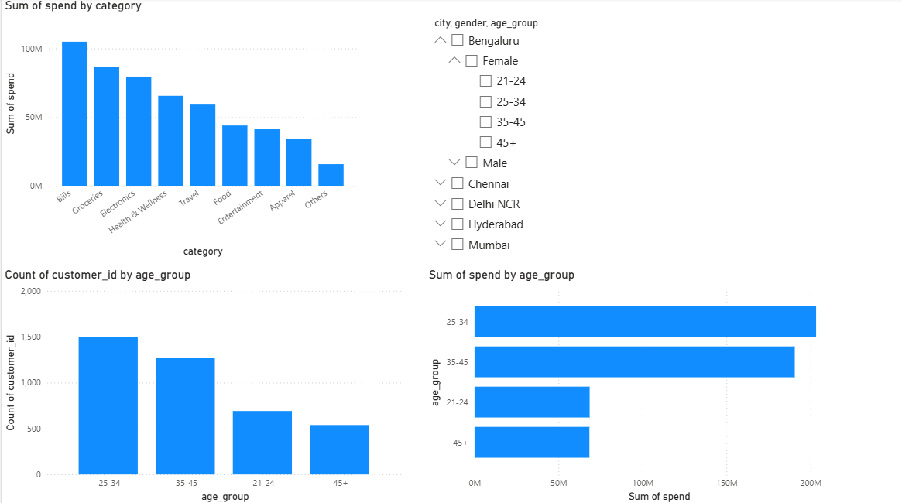
👥 Customer Demographics & Spending Patterns
- 25–34 age group leads in both customer count and total spend, followed by 35–45
- Bills, Groceries, and Electronics are the top spending categories
- Younger customers (21–24) show lower spend intensity, while 45+ is smaller but stable
- Spending is driven by working-age urban customers, indicating strong lifestyle and utility-led usage

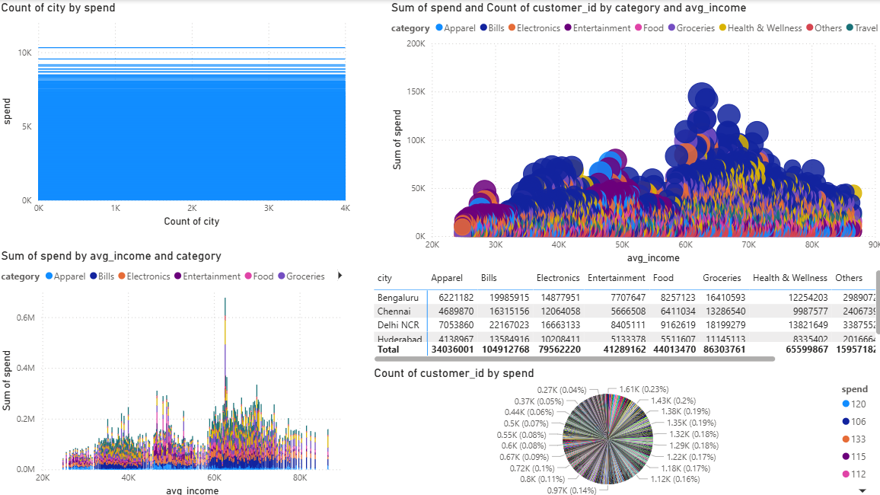
💰 Income-Based Spending & Category Insights
- Spending increases with income, peaking in the ₹55K–₹75K range
- Bills and Groceries dominate across all income bands, showing essential-led spending
- Discretionary categories (Electronics, Travel, Entertainment) rise sharply at higher incomes
- Metro cities contribute the bulk of high-income, high-spend customers

